logo

**Table of Contents**

UM0166 Realtek RTL8710AF IFTTT Example Guide

1 Introduction to IFTTT 3

2 Setting up an IFTTT account. 3

3 Creating the applet for Ameba/RTL8710AF 3

4 Programming the Ameba/RTL8710AF to post the trigger. 7

# Introduction to IFTTT

If This Then That, also known as IFTTT is a free web-based service to create chains of simple conditional statements, called applets. An applet is triggered by changes that occur within other web services such as Gmail, Facebook, Telegram, Instagram, or Pinterest. For example, an applet may send an e-mail message if the user tweets using a hashtag, or copy a photo on Facebook to a user's archive if someone tags a user in a photo.

# Setting up an IFTTT account.

In order to be able to use the IFTTT service it is necessary to make an account at <https://ifttt.com/>

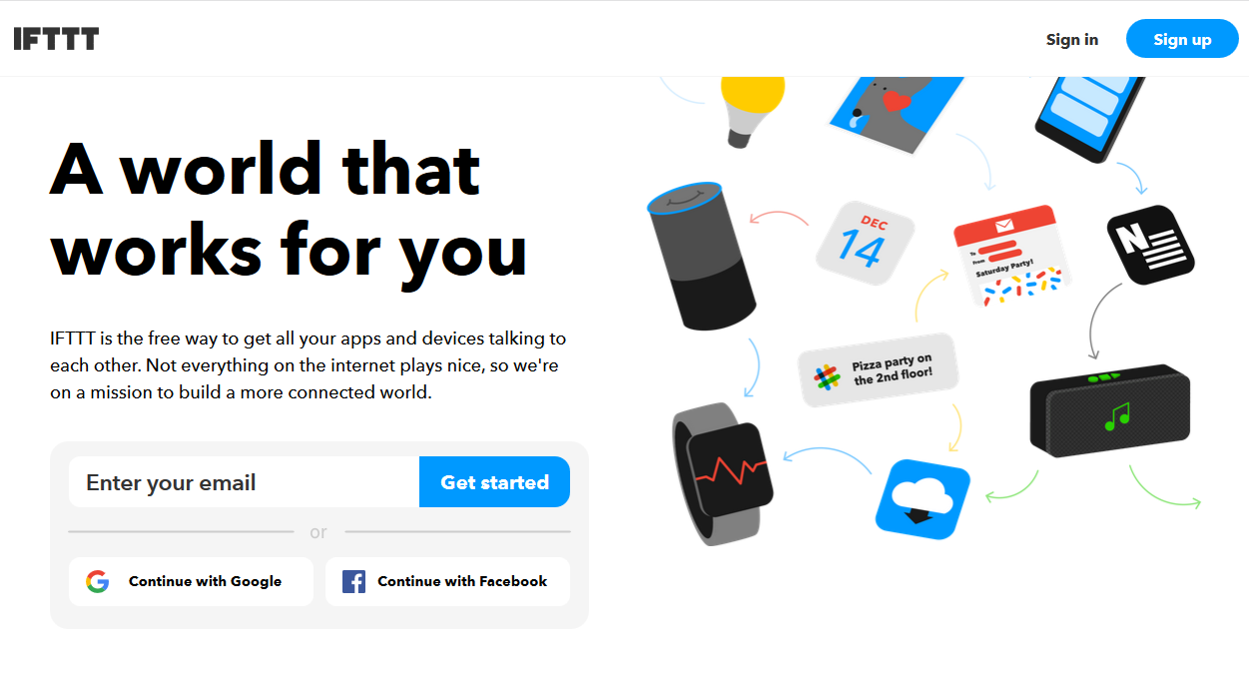

Once logged in the home page of IFTTT is visible. There are many cloud services and online services that are integrated with the IFTTT platform.

# Creating the applet for Ameba/RTL8710AF

In order to run this example we use the HTTP POST feature of the ameba to post to a simple webhook service that is received by the IFTTT platform which can in turn be used to trigger a response. In this example the response that we have used is to send an Email. Hence when the Ameba board posts the HTTP request an email is sent to the recipient specified in the IFTTT applet.

* Click on the “My Applets” option from the home page after logging in



* Once in the applets page, select “New Applet”

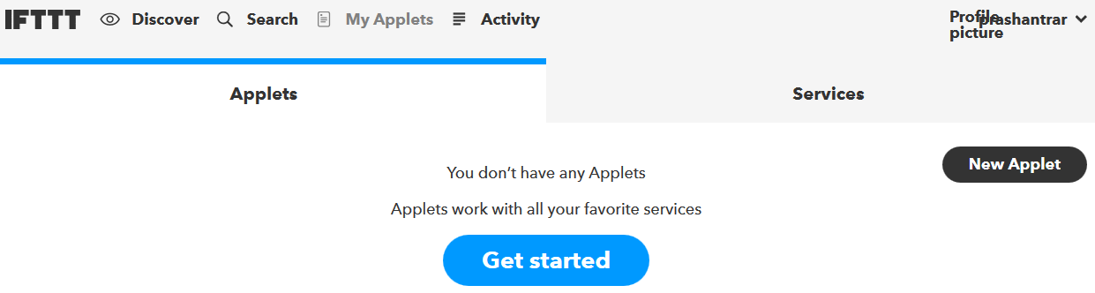

* Once in the New Applet page, click on the “this” option as shown below in order to select the trigger.

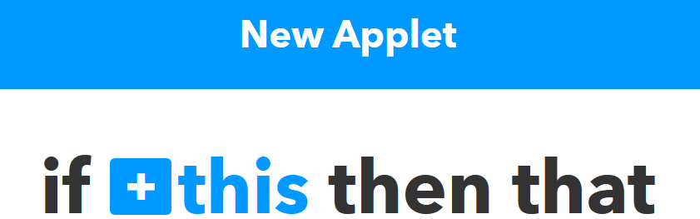

* Once inside the option, choose the “webhooks” service from the list of services as shown below. You can use the search bar to find the service.

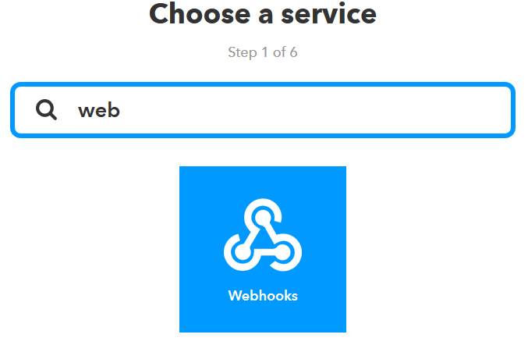

* Once you choose the service, it shows you the triggers available with the service. In case of webhooks there is only one trigger that the service provides which is “Receive a web request”

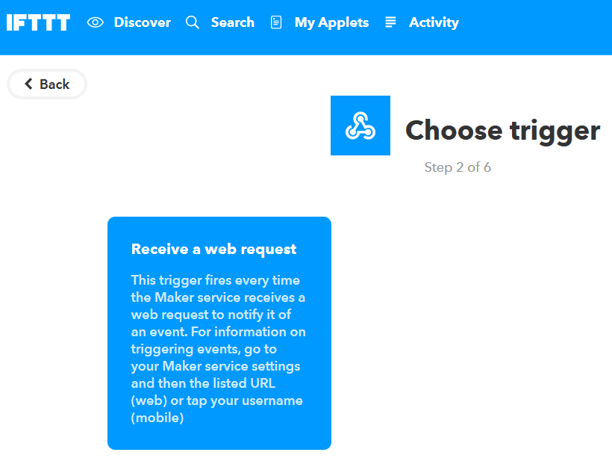

* Once the “Receive a web request” is selected, an event name that needs to be supplied to identify the trigger successfully. For the demonstration of this example the Event name is set as “test_event”

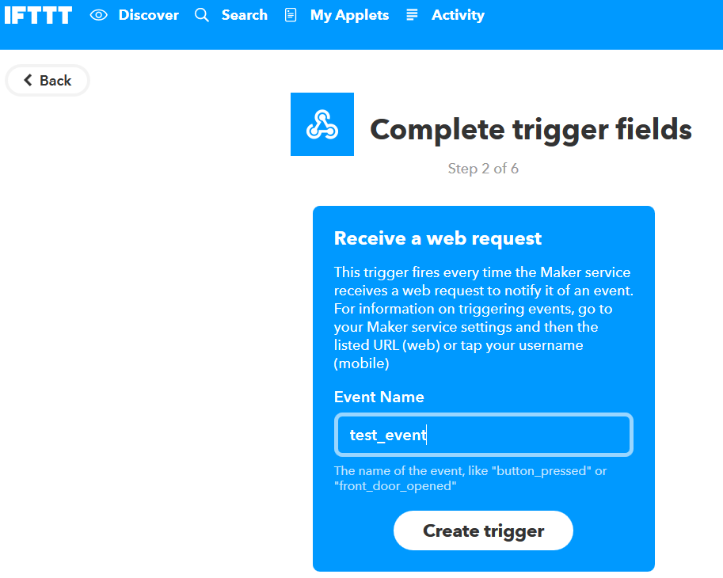

* Once the event name is set, click “create trigger” to finish creating the trigger.
* Once the trigger is create we move on to choosing the “That” field to create the action that needs to be taken upon receiving the trigger.



* For this example upon receiving the webhook trigger from ameba we choose the email service as the action taken in response to the trigger and hence we choose email from the list of services.

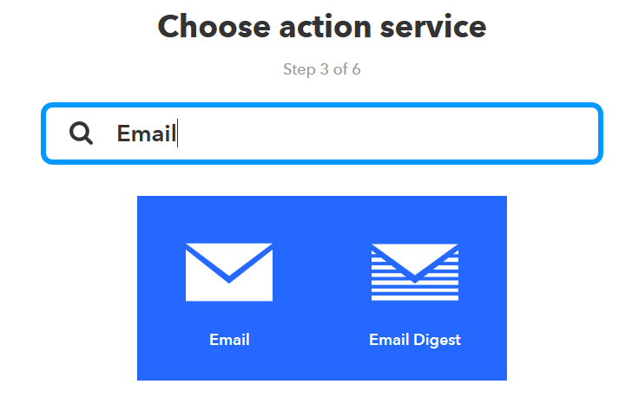

* Once the action service is selected, a list of actions that the service can provide is listed, in this demonstration, the email service is capable of providing only one action “Send me an email” and hence we choose this action

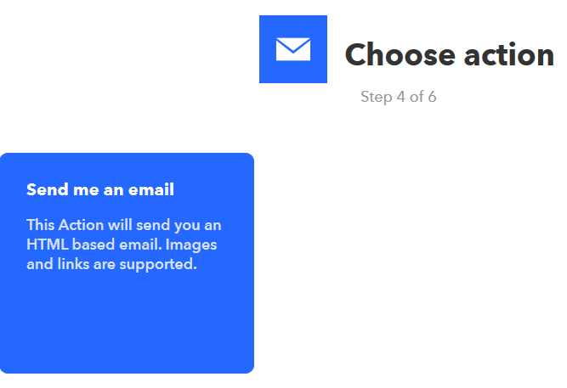

* Once you select the “Send me an email” action, in the next page you can choose to edit the contents of the subject and body of the email that will be sent to you.

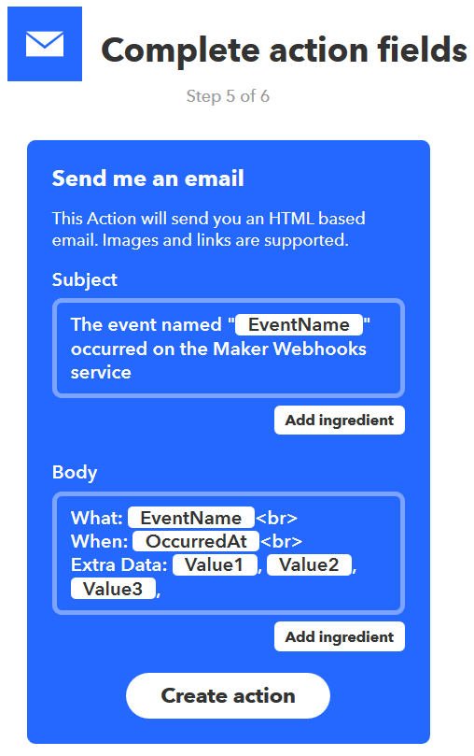

* If needed the subject and body can be edited and you can click “Create action” to finish creating the response. It is to be noted here that the “Email” service sends an email as response to the mail ID that is registered to create the IFTTT account.
* Once you have finished setting the trigger and response, click on finish to finish creating the applet.

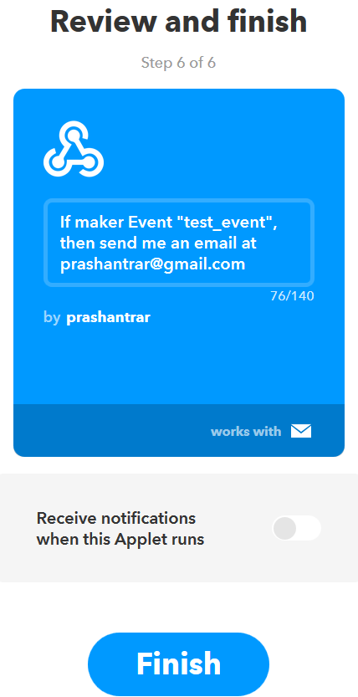

* Once finished the applet is visible under the “My Applets” section in your IFTTT home page.

# Programming the Ameba/RTL8710AF to post the trigger.

Once the applet is setup In the IFTTT dashboard, we need to use the example program to flash onto the board to post the HTTP request.

The example program is under the folder “HTTP_IFTTT_POST”

* Click on the .ino file inside the example folder to open the example with the Arduino IDE by default.
* Once the program is open, 3 things need to be edited inside the code in order to make it work successfully.
  1. Edit the wi-fi credentials in order to connect to the wi-fi hotspot or access point of your choice.
  2. In the host name field enter the hostname of the IFTTT service “maker.ifttt.com”
  3. In the Path field enter the following “trigger/<Event Name>/<key>”
  4. The event name should be same as the one specified in the IFTTT applet as shown below:

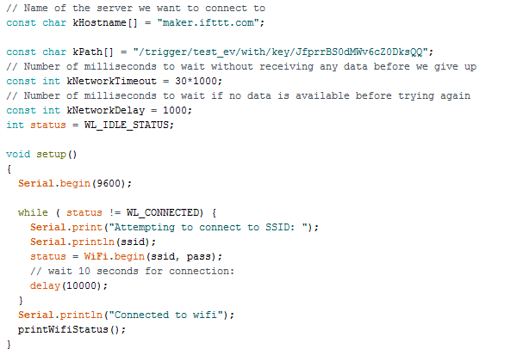

* In order to obtain a key, you need to look at the documentation tab of the webhooks service in your IFTTT account once you are logged as shown below.
* You can look up the web hooks service in the service tab.

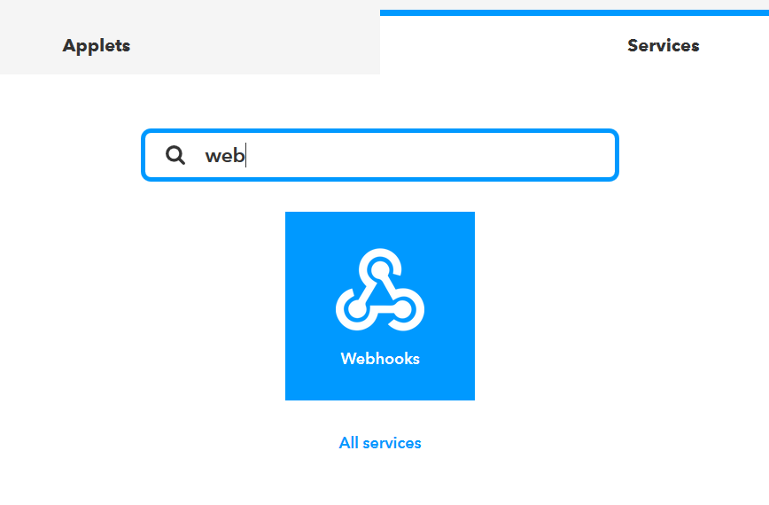

* Once you click on webhooks, you reach the webhooks service page and then you can click on the “Documentation” tab on the top right corner.

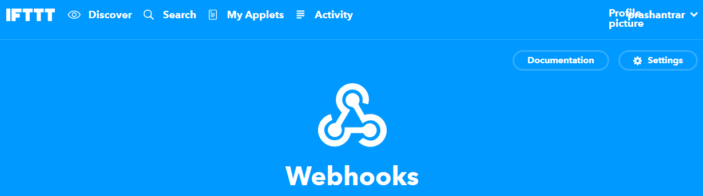

* In the documentation page, you will be able to see your key and how the HTTP request can be used as shown below.

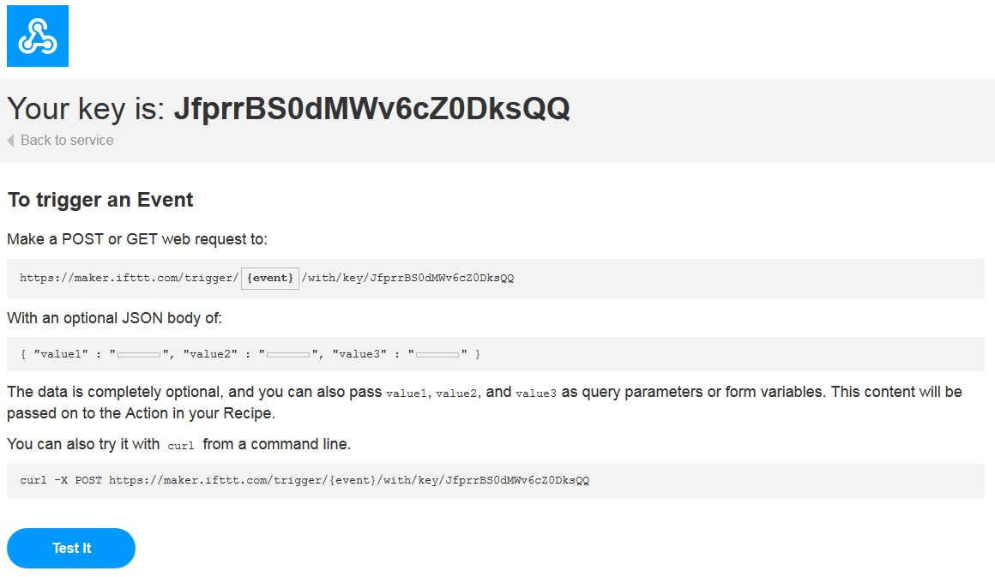

* Once the board is flashed, you can open the serial monitor on the Arduino IDE to see the logs if the event has been successfully fired.

